Studio Envelope website
https://www.studioenvelope.com/

- Website references:
https://www.studiogoya.in/
https://maiadesign.in/
https://www.studioruh.in/

Home Page
- Top left- Logo
- Top right / center- Access buttons
Home|About|Projects|Services|Contact|Instagram
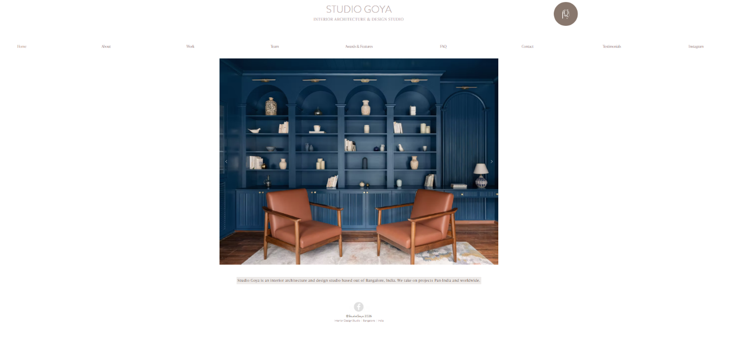
Art. Interiors. Architecture < as discussed>
With reference to this home page-
I shall select 1 image-
Below/on it- can be the tag line: Spaces, sealed with care.
About Page
These items can come to this page:
Why an envelope? Description< already added>
About me < already added>
I can share a note about me for more text and professional set up
Will also share a photo of me to add on one side

Project Page
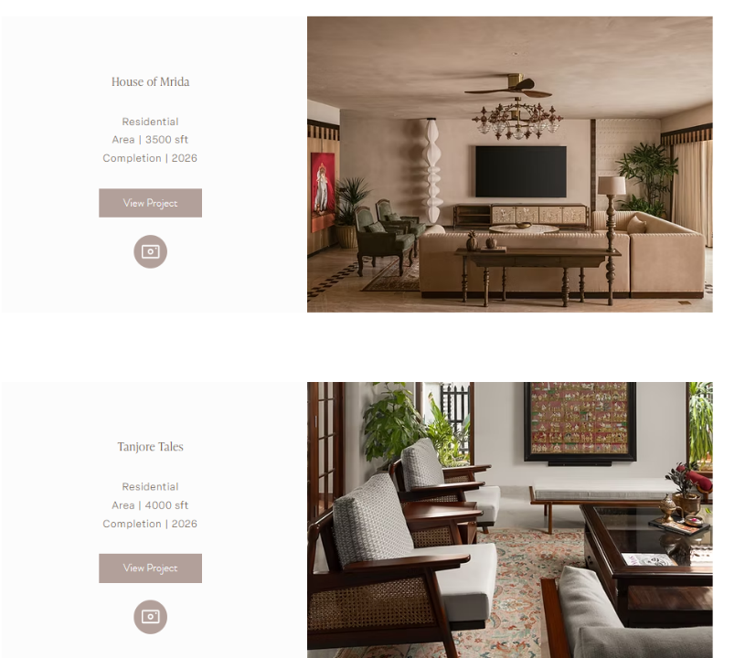
Taking this as reference, for each project, I will select an image and share.
Details to include:
Name <bigger font size>
Location
Area
Scope
Year of completion

Services Page
- Design Consultation
- Space Planning
- Colour Consultation
- Material Selection
- Lighting Consultation
- Furniture Selection
- Soft Furnishing Selection
- Décor Consultation

- Project Management
- Technical services include: Demolition & construction, electricals, plumbing, false ceiling, stone & tiling
- Coordinating with vendors & contractors

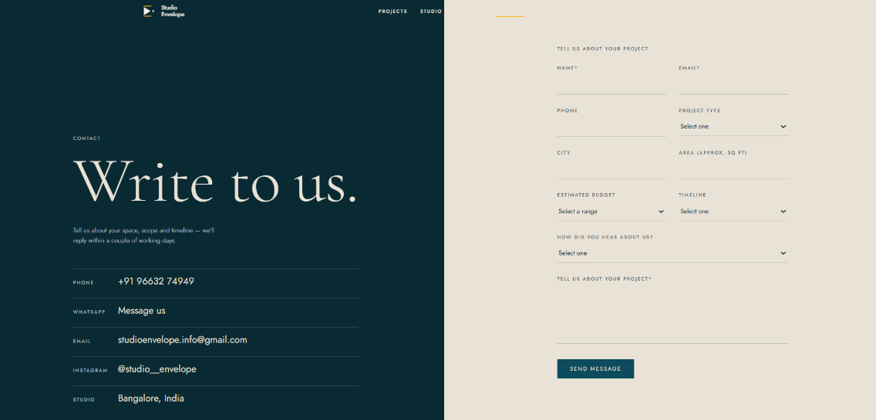
Contact Page
<This has everything as such needed>

Instagram Page
<Clicking on this can take them to my Instagram handel>
